**CONNECT GIT WITH OUR PROJECT**

SE DEBE CREAR UN WORKSPACE EN LA CARPETA HOME DEL SISTEMA PARA LUEGO UBICARSE A TRAVÉS DE BASH:

OPEN GIT BASH

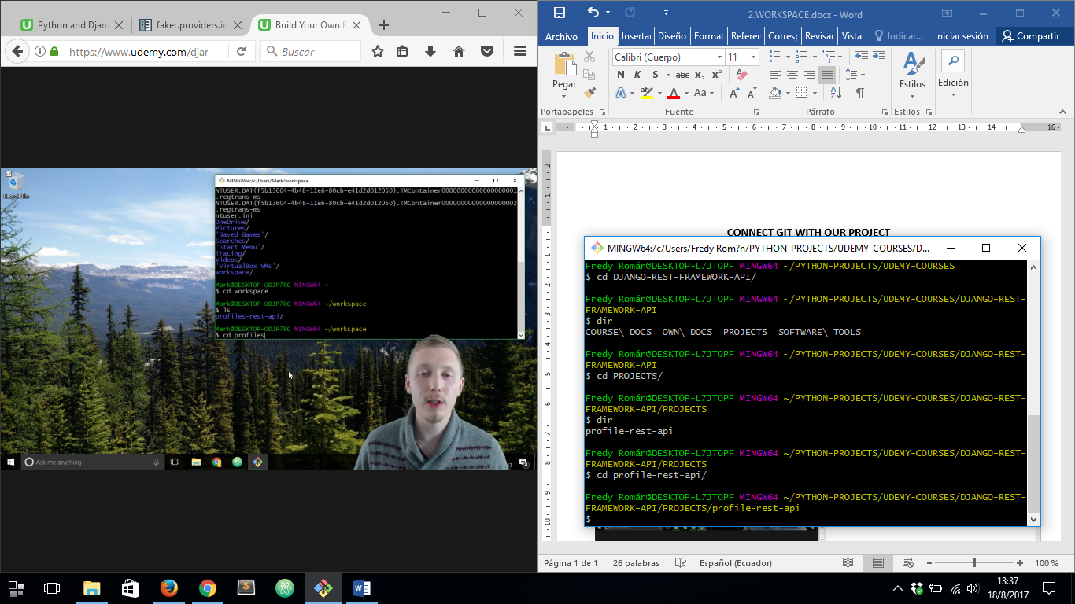

**INITIALIZE MY PROJECT WITH A GIT REPOSITORIE**

FIRST WE MUST CREATE A README.md FILE INSIDE OUR PROJECT FOLDER:

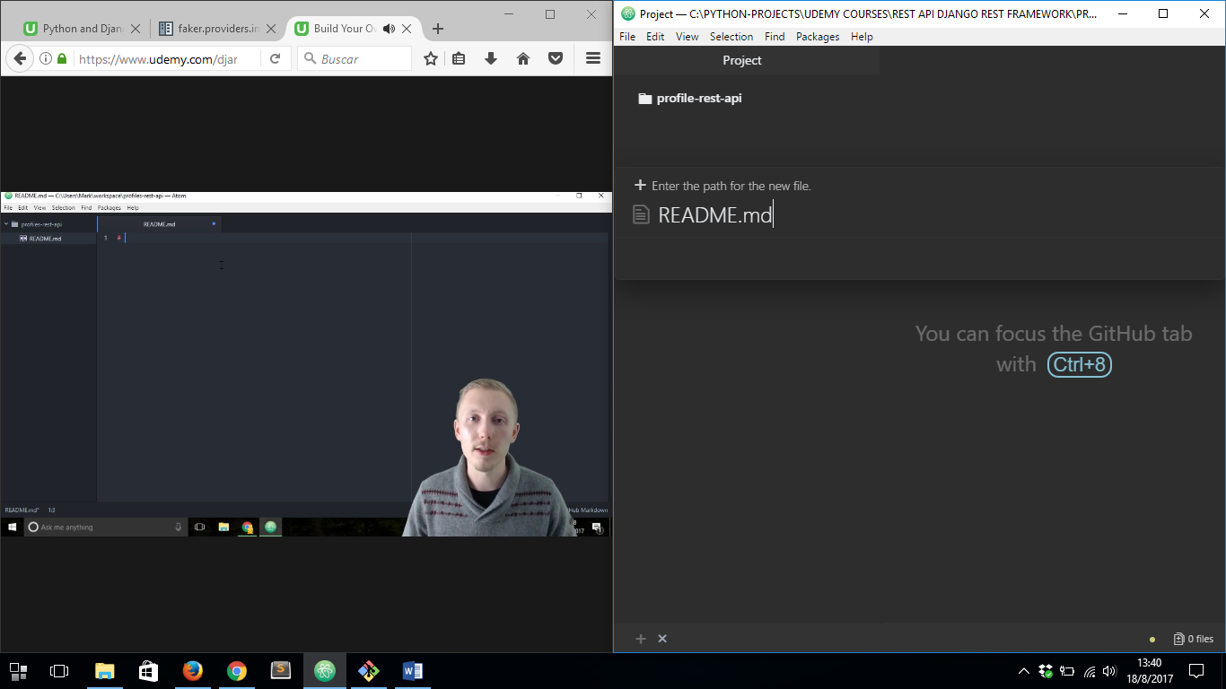

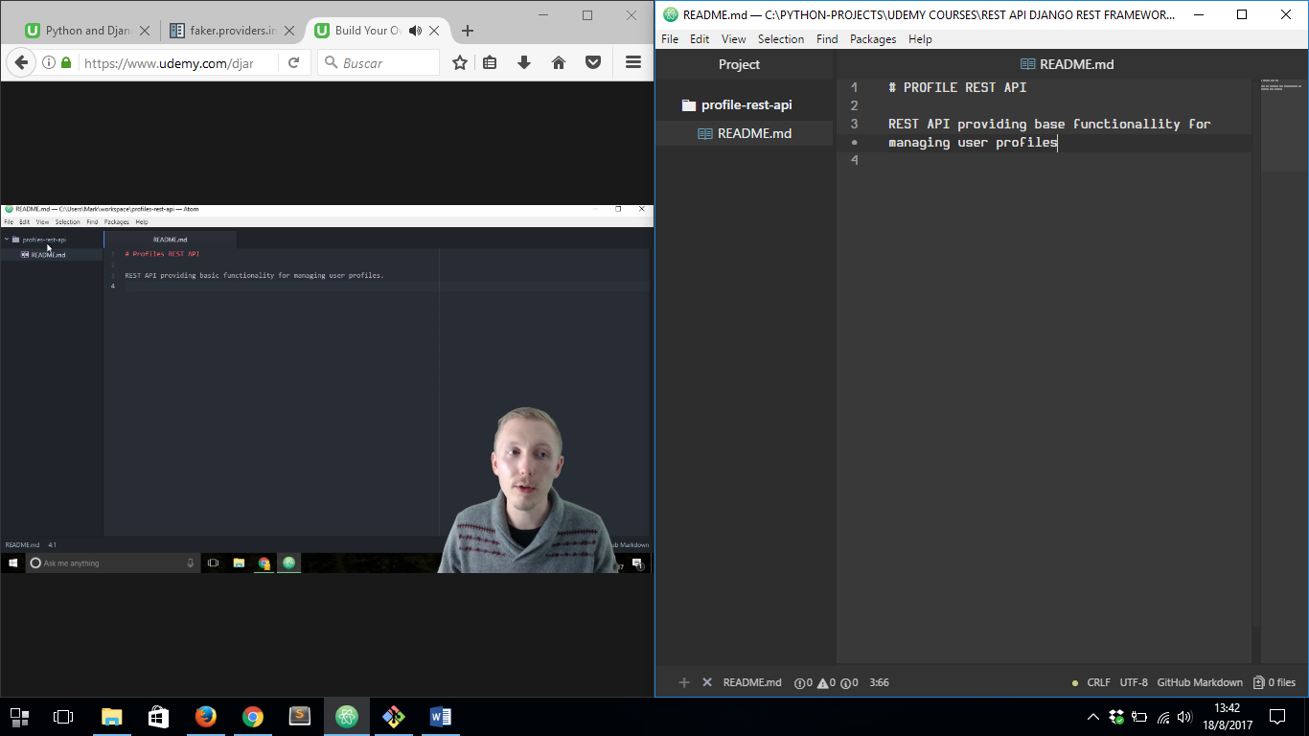

THEN IT’S NECESSARY TO CREATE A ***.gitignore*** FILE INSIDE THE PROJECT FOLDER:

THEN WE MUST COPY THE CODE INSIDE THIS PAGE AND PASTE INTO THE FILE MENTIONED ABOVE : <https://gist.github.com/LondonAppDev/66c3291e4f487ac92fcc96735e44c35e>

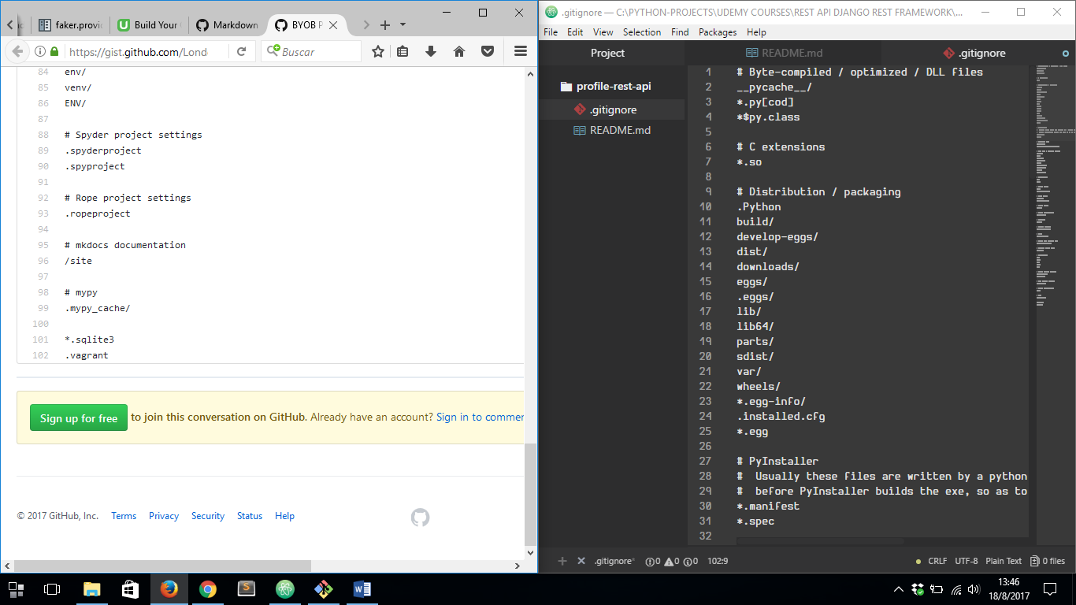

THEN WE CAN INITIALIZE OUR PROJECT INTO GIT REPOSITORY WITH ***git init*** COMMAND

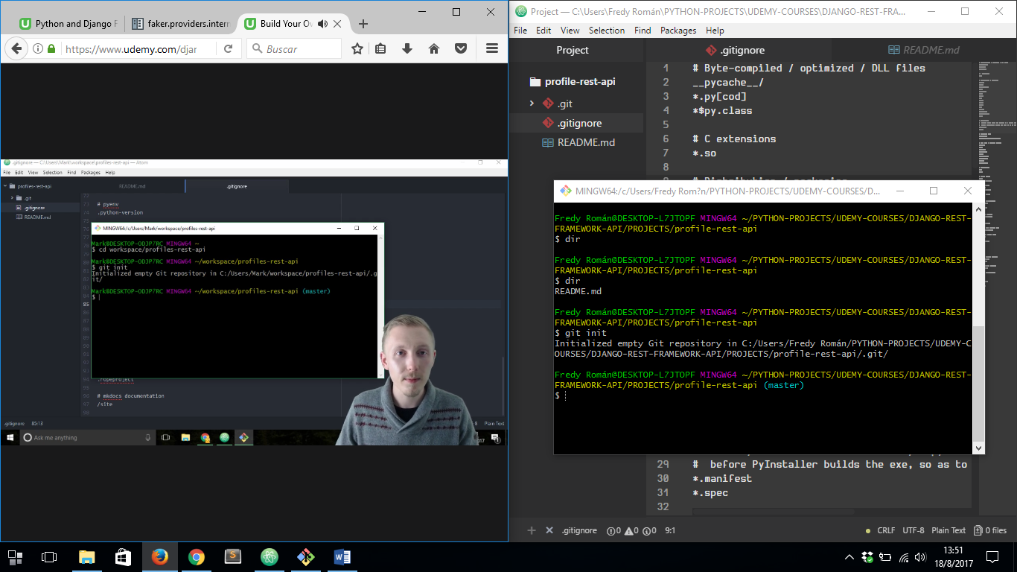

AFTER THAT WE MUST ADD THIS PROJECT TO THE REPOSITORY

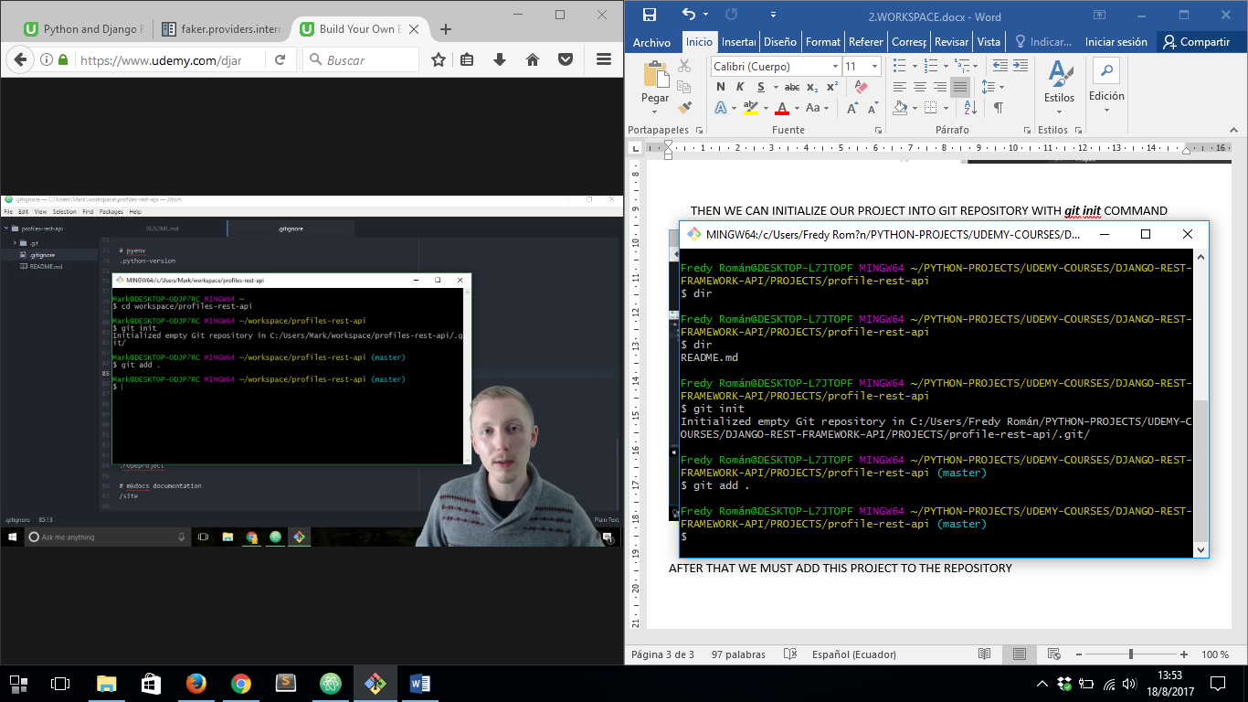

FINALLY WE MUST DO THE FIRST COMMINT OF THE PROJECT

BUT WE MUST SPECIFY SOME INFORMATION FIRST:

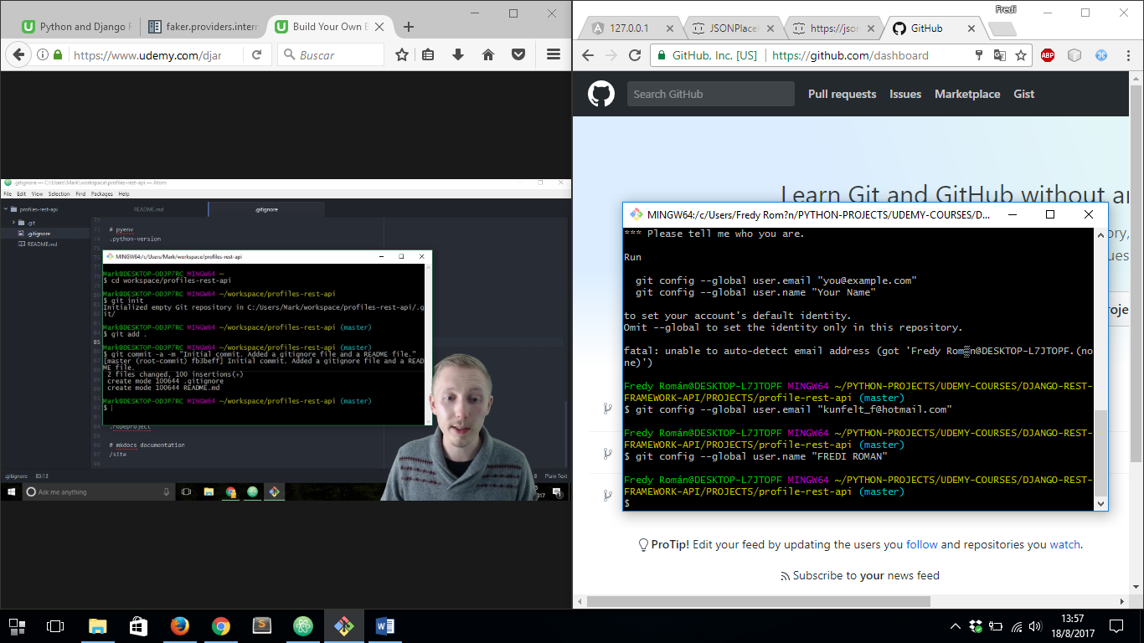

THEN WE CAN DO FIRST COMMINT:

